9647,9746 H2 Chemistry P3 answer 2010

1 |  | ai |  | Step 1 -LiAlH₄/dry ether, or H₂/Ni, heat
 |  |  |  | Step 2 – HCN/traces of NaCN or NaOH, 10⁰C – 20⁰C
 |  | aii |  | Planar structure of carbonyl group allows nucleophile CN⁻ to approach from either sides of the plane with equal probability, resulting in the formation of racemic mixture whereby the isomers cancel out the optical activity.
 |  | bi |  | nucleophile
 |  | bii |  | Nucleophilic addition mechanism
 |  |  |  | 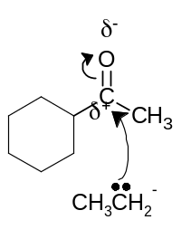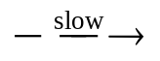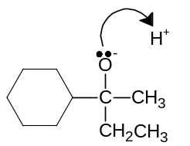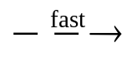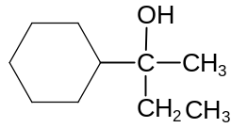
 |  | ci |  | 2M(NO₃)₂ → 2MO + 4NO₂ + O₂
 |  | cii |  | Down the group, thermal decomposition temperature of nitrates increases.  Down the group, charge density of metal cation decreases, polarizing ability decreases. Distortion of the electron cloud of nitrate decreases, hence weakening of N-O bond decreases. Thermal stability of nitrates increases, therefore temperature for decomposition increases.
 |  | di |  | The close proximity in energy of 3d and 4s electrons allows iron to absorb similar amount of energy to form ions of roughly same stability by losing different number of electrons.
 |  | dii |  | Fe²⁺ provides an alternative route with a lower activation energy as Fe²⁺ overcome the repulsion between the two negatively charged S₂O₈²⁻ and I⁻.  2Fe²⁺ + S₂O₈²⁻ → 2Fe³⁺ + 2SO₄²⁻ E_{cell} = 2.01-0.77 = 1.24V  2Fe³⁺ + 2I⁻ → 2Fe²⁺ + I₂ E_{cell} = 0.77-0.54 = 0.23V
2 |  | ai |  | For (CH₃)₃Br, concentration of halogen doubles, while concentration of OH⁻ remains constant, rate doubles. First order with respect to (CH₃)₃Br. By inspection, concentration of OH⁻ doubles while [(CH₃)₃Br] remains constant, rate remains unchanged, hence zero order with respect to OH⁻.Rate = k[(CH₃)₃Br]  For CH₃CH₂CH₂CH₂Br , Rate = k [CH₃CH₂CH₂CH₂Br][ OH⁻]
 |  | aii |  | SN1 for (CH₃)₃Br
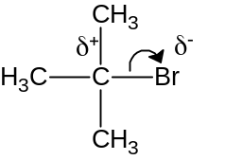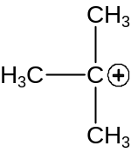
+ Br ⁻

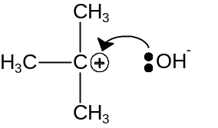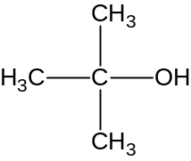

SN2 for CH₃CH₂CH₂CH₂Br,

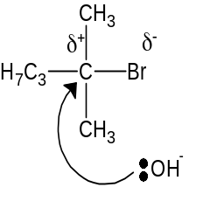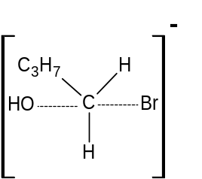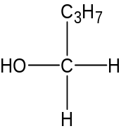

 |  |  | aiii |  | Energy profile for (CH₃)₃Br  E_{a}  reactive intermediate  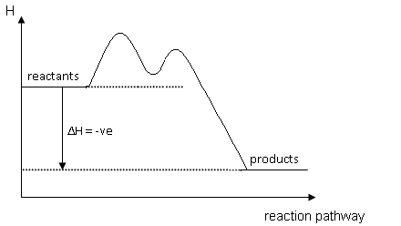  reactive intermediate  Energy profile for CH₃CH₂CH₂CH₂Br  transition state  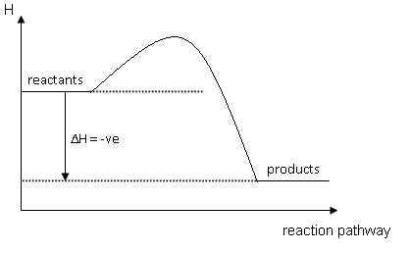  E_{a}  where transition state is
 | b |  |  | Reducing strength of the HCl < HBr < HI.  Hence HCl cannot reduce H₂SO₄. HBr and HI reduce H₂SO₄ , hence brown Br₂(g) and violet I₂(g) form respectively. HBr being weaker reducing agent than HI reduces H₂SO₄ to SO₂ while HI reduces H₂SO₄ to H₂S.  NaCl + H₂SO₄ → HCl + NaHSO₄  2HBr + H₂SO₄ → Br₂ + SO₂ + 2H₂O  8HI + H₂SO₄ → 4I₂ + H₂S + 4H₂O
 | ci |  |  | 3Cl₂ + 6NaOH → 5NaCl + Na ClO₃ + 3H₂O
 | cii |  |  | Vol of Cl₂ = 20/100 X 200 = 40 m³ .  No of moles of Cl₂ = 4 X 10⁴ / 24  No of moles of NaOH = 2 X 4 X 10⁴ / 24  Vol of NaOH = 1.67 X 10⁴ dm³
3 | ai |  |  | The quaternary structure of haemoglobin refers to the spatial arrangement of its four associated subunits each with its own haem group. The quaternary structure is stabilized by the four types of R-group interactions (hydrogen bonds, ionic bonds, disulfide linkages and van der Waals forces.
 | aii |  |  | They all contain the same sequence of amino acids (primary structure), hence the R-group interactions all occur in the same positions giving rise to the same tertiary structure.
 | aiii |  |  | Extreme pH conditions will affect charged R groups containing NH₃⁺ and COO⁻ , hence affecting the extent of ionic interactions leading to a change in tertiary structure and loss of function.
 | bi |  |  | CO has a lone pair of electrons on the carbon atom available for dative bonding to a central metal atom/ion.
 | bii |  |  | Ligand exchange  Carbon monoxide is toxic as it binds much more strongly to haemoglobin compared to oxygen, hence causing the bond to be irreversible, affecting the oxygen transport ability of haemoglobin.
 | biii |  |  | Expose the patient to a supply of pure oxygen immediately
 | ci |  |  | enthalpy  Mg²⁺_{(g)} + 2e⁻ + 2Cl_{(g)}  2×ΔH_{1st E.A.} (Cl)  = −698 kJmol⁻¹  ΔH_{2nd I.E.} (Mg)  = +1450 kJmol⁻¹  Mg²⁺_{(g)} + 2Cl⁻_{(g)}  Mg⁺_{(g)} + e⁻ + 2Cl_{(g)}  ΔH_{1st I.E.} (Mg)  = +736 kJmol⁻¹  Mg_{(g)} + 2Cl_{(g)}  Mg_{(g)} + Cl_{2(g)}  B.E (Cl₂)  = +244 kJmol⁻¹  ΔH_{latt.} (MgCl₂)  Mg_{(s)} + Cl_{2(g)}  ΔH_{atom} (Mg)  = +148 kJmol⁻¹  0  ΔH_{f} (MgCl₂)  = −641.8 kJmol⁻¹  MgCl_{2(s)}  LE = -2521.8 kJ mol⁻¹
 | cii |  |  | The theoretical lattice energy is based on a pure ionic model, but MgCl₂ exhibits some covalent character due to the high polarizing power of Mg²⁺ which distorts the electron cloud of the Cl⁻ ion.
 | d |  |  | NaCl (s) +aq → Na+ (aq) + Cl- (aq) ; pH = 7  MgCl₂ (s) + aq → [Mg(H₂O)₆]²⁺ (aq) + 2Cl⁻ (aq)  [Mg(H₂O)₆]²⁺(aq)  [Mg(H₂O)₆(OH)]⁺(aq) + H⁺(aq) ; pH= 6.5  Al₂Cl₆(s) + 12H₂O(l) → 2[Al(H₂O)₆]³⁺(aq) + 6Cl⁻(aq)  [Al(H₂O)₆]³⁺(aq)  [Al(H₂O)₅(OH)]²⁺(aq) + H⁺(aq) ; pH = 3
 | e |  |  | MgCl₂ (aq) + 2NaOH (aq) → Mg(OH)₂ (s) + 2 NaCl (aq)  pH = 10.2 ⇒ pOH = 3.8  [OH⁻] = 1.58 x 10⁻⁴ mol dm⁻³  Ionic product = K_{sp} = [Mg²⁺][OH⁻]²  = 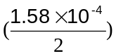(1.58x10⁻⁴)²  = 2.0 x 10⁻¹² mol³dm⁻⁹
4 | ai |  |  | Cathode: Cu and Anode: Br₂
 | aii |  |  | Q = 3 x 60 x 60 = 10800 C Cu²⁺ + 2e → Cu  Moles of electrons = 10800/96500 = 0.112 mol or 2(96500) = 63.5  Moles of copper = 0.112/2 = 0.0560 mol 3X60X60 m  Mass of copper = 0.0560 x 63.5 = 3.56 g m = 3.56g
 | bi |  |  | In propagation step, two alkyl radicals are formed. They are the more stable tertiary (CH₃)C° and less stable primary (CH₃)₂CCH₂°. More stable alkyl radical results in the formation of major product while the less stable radical results in the formation of minor product.
 | bii |  |  | Bond energy of F₂ = 158 kJ mol⁻¹ , while bond energy of Br₂ = 193 kJmol⁻¹. Fluorine will react more vigorously because the F-F bond is weaker than Br-Br bond according to bond energies.
 | biii |  |  | Bond between C-I and I-I are so weak , they break and form readily. Hence reaction becomes reversible.
 | ci |  |  | J = 2-bromopentane, K = 2-pentene, L = 1-pentene, M = butanoic acid,  N = ethyl butanoate  CH₃CH₂CH₂CHBrCH₃ + KOH → CH₃CH₂CH=CHCH₃ + KBr + H₂O  (or CH₃CH₂CH₂CH=CH₂)  CH₃CH₂CH₂CH=CH₂ + 5[O] → CH₃CH₂CH₂COOH + CO₂ + H₂O  CH₃CH₂CH₂COOH + CH₃CH₂OH → CH₃CH₂CH₂COOCH₂CH₃ + H₂O
 | cii |  |  | Cis-trans or geometric isomerism . Draw cis-2-pentene and trans-2-pentene
5 | ai |  |  | H₂PO₄⁻ + OH⁻ → HPO₄²⁻ + H₂O  HPO₄²⁻ + H₃O⁺ → H₂PO₄⁻ + H₂O
 | aii |  |  | [NaH₂PO₄] in buffer = 0.0625 moldm⁻³  [Na₂HPO₄] in buffer = 0.0375 moldm⁻³  pH = 7.2 + lg{0.0375/0.0625} = 6.98
 | aiii |  |  | [HCl] = 0.00244 mol dm⁻³  Decrease in concentration of Na₂HPO₄ = (30X0.1/1000)-(2X0.1/1000)  =2.8 X10⁻³ X1000/82 = 0.0342 moldm⁻³  Increase in concentration of NaH₂PO₄ = (50X0.1/1000)+( 2X0.1/1000)  =5.2 X 10⁻³ X1000/82 = 0.0634  pH =6.93 ; change in pH = 0.05
 | bi |  |  | heat evolved, q = 80 x 4.2 x 6.5 = 2184 J  no of moles of water formed = 0.0400 mol  ΔH^{θ}_{neut} = -2184/0.04 = -54.6 kJmol⁻¹
 | bii |  |  | ΔG = ΔH - TΔS = -54.6 – 298(80.6 x 10⁻³) = -78.6 kJmol⁻¹ < 0  Since ΔG < 0, the reaction is spontaneous.
 | c |  |  | Cl has a smaller atomic radius than I. Bond energy of HI is smaller than HCl, thermal stability of HCl is greater than HI. Therefore with same amount of heat from hot glass rod, HI dissociates readily to form violet fumes but HCl remains unchanged.
 | di |  |  | 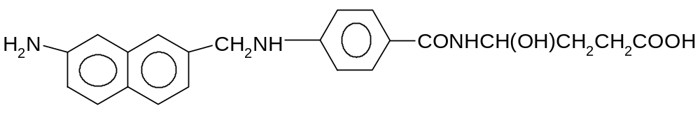  I  II
 |  |  |  | I = pK_{b2 ,} II = pK_{b1} , lone pair of electrons on N of II is more available for dative bonding with H⁺ due to the presence of electron donating R group.
 | dii |  |  | 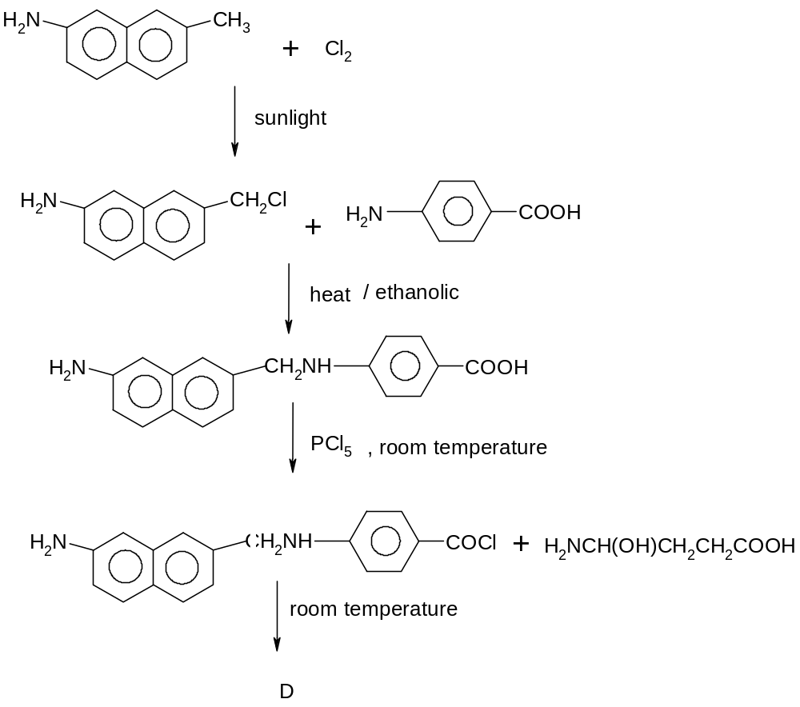
 | e |  |  | Step 1 – aqueous NaOH and heat  Step 2 – aqueous Br₂ , Br₂ decolourised by phenylamine

End of Paper

